ES6 Assignments

Aditya Yadav

1. **Constants:** Declare a constant & confirm its value cannot be changed.

Here I’ve used colors and constant

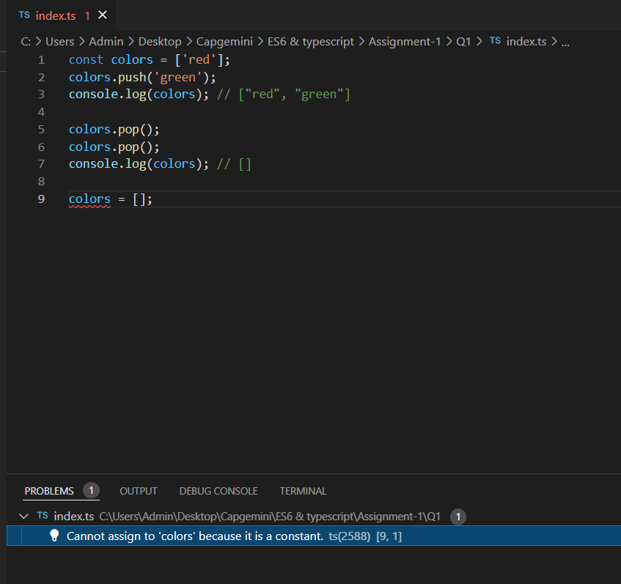

1. **Scoping:** Declare a variable inside if condition & make sure that it is not accessible outside if condition.

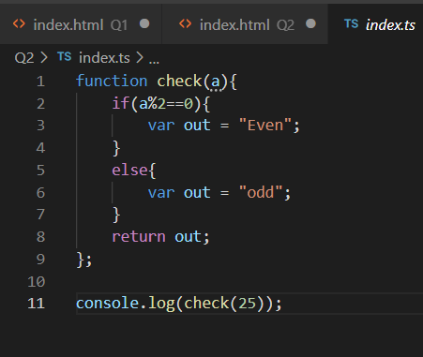

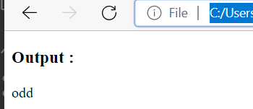

1. **Enhanced object properties:** Create an ‘Order’ object having data members ‘id’, ‘title’, ‘price’. Add the methods printOrder() & getPrice(). Now, copy the order object using Object.assign().

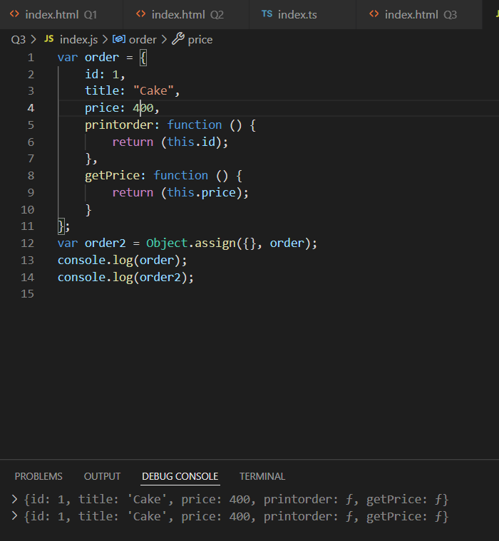

**4. Arrow functions:** Take an array of strings & convert it into another array of object which has two properties {string, string_length}. For example:

let names = [‘Tom’, ‘Ivan’, ‘Jerry’]

Output: [ {name: ’Tom’, length: 3}, {name: ’Ivan’, length: 4 }, {name: ’Jerry’, length: 5} ]

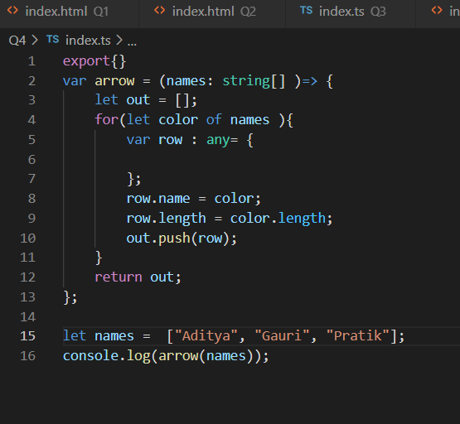

**5. Extended parameter handling:**

* 1. Write a add() with default values.
  2. Write a function userFriends() that takes 2 arguments username & array of user friends. The function should print username & his list of friends. (Use rest parameters)
  3. Write a function printCapitalNames() that takes five names as argument & prints them in capital letters. Use spread operator in order to call printCapitalNames() funct

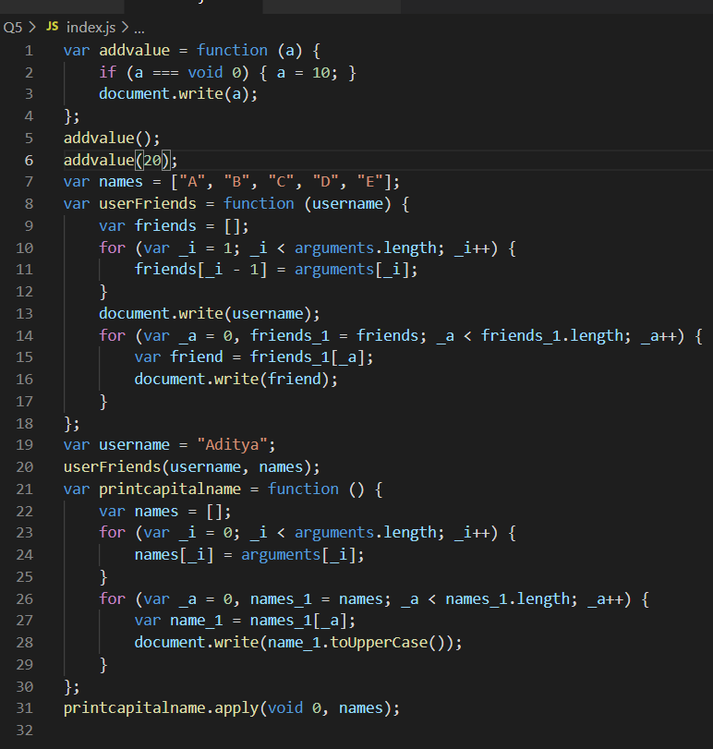

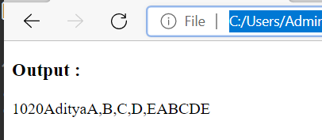

**6. Template literals:** Draft a ticket to Sysnet that describes problem with your laptop. Use ‘template literals’ to add value of laptop model, your desk no, your name etc.

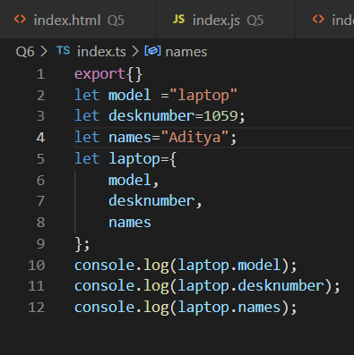 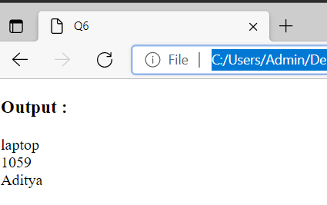

**7. De-structuring assignment:**

* 1. Suppose there is a javascript array with 4 elements. Print the value of 3rd element using array matching.
  2. Create an organization object having attributes name, address. Write a program to retrieve pin code of an address using object deep matching.

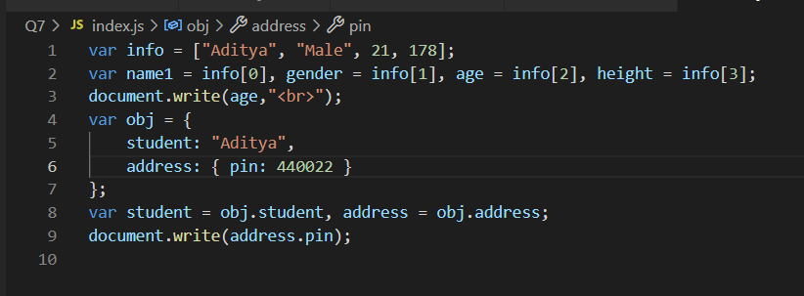

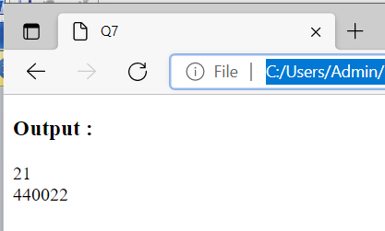

**8. Classes & Modules:** Write a class Account with attributes id, name, balance. Add two sub classes SavingAccount & CurrentAccount having specific attribute interest & cash_credit respectively. Create multiple saving & current account objects. Write a functionality to find out total balance in the bank.

